**RESUME**

Credit Notes Process has as function update information into JD Edwards application and Run My Process application. For this process Digital Innovation Team of Imerys provide of direct connection with Run My Process through SQL Server table in RPA database. In this table the robot update information into Run My Process application, also take the necessary information and with this information update credit notes in JD Edwards application.

**INTRODUCTION**

Credit Notes is a

**SQL TABLES**

1. **CreditsNotesEmea** is a SQL Server table. This table was created byDigital Innovation Team of Imerys and provide of direct connection with Run My Process through SQL Server table in RPA database. This has the next structure:

[RequestID] [varchar](max) NULL,

[CreatedBy] [varchar](max) NULL,

[CreatedOn] [varchar](max) NULL,

[RequestStatus] [varchar](max) NULL,

[Market] [varchar](max) NULL,

[SubMarket] [varchar](max) NULL,

[Category] [varchar](max) NULL,

[SubCategory] [varchar](max) NULL,

[Rebill] [varchar](max) NULL,

[Correction] [varchar](max) NULL,

[TypeOfRequest] [varchar](max) NULL,

[TextToShowOnCustomerDoc] [varchar](max) NULL,

[Reason] [varchar](max) NULL,

[CSAssistant] [varchar](max) NULL,

[ShipToCustomerNumber] [varchar](max) NULL,

[ShipToCustomerName] [varchar](max) NULL,

[Country] [varchar](max) NULL,

[OrderNumber] [varchar](max) NULL,

[AccountManager] [varchar](max) NULL,

[InvoiceNumberToBeCredited] [varchar](max) NULL,

[CirculationList] [varchar](max) NULL,

[ReturnOrderNumber] [varchar](max) NULL,

[ProductNumber] [varchar](max) NULL,

[ProductDescription] [varchar](max) NULL,

[LegalEntity] [varchar](max) NULL,

[DespatchSite] [varchar](max) NULL,

[ErpImplementationContact] [varchar](max) NULL,

[ComplaintReference] [varchar](max) NULL,

[QuantityToBeCredited] [varchar](max) NULL,

[CustomerCurrency] [varchar](max) NULL,

[ValueOfRequest] [varchar](max) NULL,

[ExchangeRate] [varchar](max) NULL,

[ValueForApproval] [varchar](max) NULL,

[CnDnNumber] [varchar](max) NULL,

[ERP] [varchar](max) NULL,

[Environment] [varchar](max) NULL

Each of these columns are fields in Run My Process and contain the necessary information to complete and update information into JD Edwards

1. **RunMyProcessData** is a backup table. In this table are saved the records with full information from **CreditsNotesEmea** table but **RunMyProcessData** has 3 extra columns.

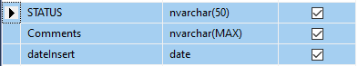

First column “STATUS” contains state of the transact. The state can be FAILED or COMPLETED if the status is FAILED the column Comments will have the possible error and the system error if STATUS has COMPLETED the columns Comments will be empty. The last column has datetime value of the day it was insert into this table; this column is the filter in select sentence for create report file which will then be sent by email to the user because the file must contain of records the same day.

**STRUCTURE OF THE PROCESS IN AUTOMATION ANYWHERE**

The process is composed for three folder and a main task. Each folder has small task with specific functions and together form the Credit Notes automation process

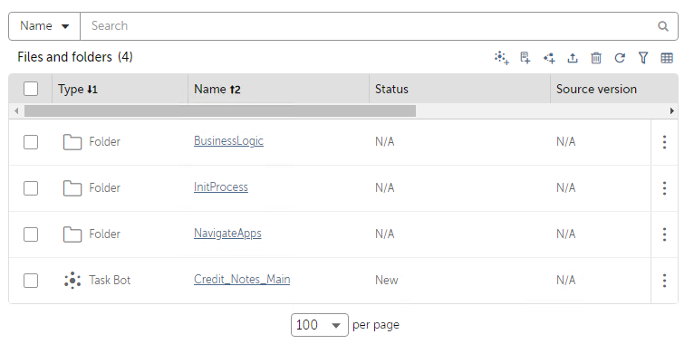

**ROBOT COMPONENTS IN AUTOMATION ANYWHERE**

Credit Notes Process is modularized on small task, each of these with specific functions. This process has a main task, this call the others task in order of execution. Details of each task are given below.

1. **Main task**



**Credit_Notes_Main** task call others task in order of execution with specific functions. This task has ten lines of code. First this task gets config data from config file, second send email with start message, third call **ReadDataSQL** task, fourth call **JDEdwardsLogic** task and finally close all windows and the process end.

1. **Init process**



Init process folder has a task that prepare the data for processing



**ReadDataSQL** task read new data for processing from **CreditNotesEmea** table localized in **RPA** database in **ussvahc071** server. Then insert the data in **RunMyProcessData** table localized in the same database and server.

1. **Business Logic and Navigate app’s**



This folder contains all process necessary to complete information in JD Edwards and Run My Process. These processes are information validation, data processing, update data in databases and the construction of the execution report file.

This folder only has one task that contains all business logic



This task read the data to be processed from **RunMyProcessData** table filtering the information with **datInsert** column, Environment column and **STATUS** column in the SELECT sentence. This task reads each record and processes then according to **TypeOfRequest** column through the tasks **NavigateCreditNotes** and **NavigateDebitNotes** located in the folder **NavigateApps**.



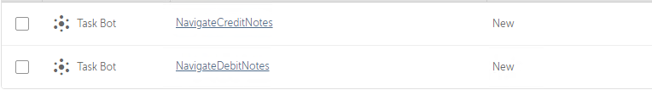

These tasks are called by **JDEdwardsLogic** and their functions are interacting with the JD Edwards app and update the information in JD Edwards and the databases according to the information provided by **JDEdwardsLogic** task according with their business rules.

**NAVIGATION AT JD EDWARDS**

The robot login to JD Edwards, it goes to “CN and DN” window, in this window select button according to type of credit note (Credit Note with stock return, Credit Note without stock return, Debit Note with stock return, Debit Note without stock return) of the transaction.

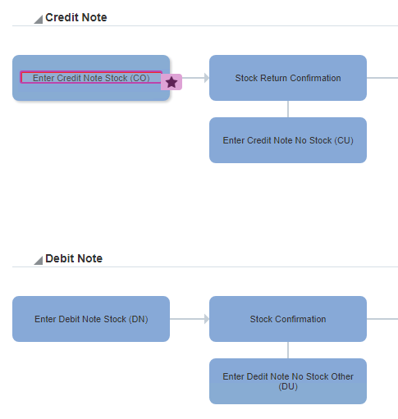

* Credit Note with stock return
* Credit Note without stock return
* Debit Note with stock return
* Debit Note without stock return

1. **Credit Notes**

The task that this process perform is **NavigateCreditNotes**

If the transaction is Credit Note, the robot will put the order number in the field Order Number and press the search button.

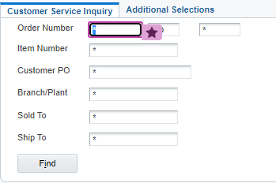



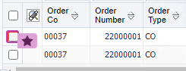

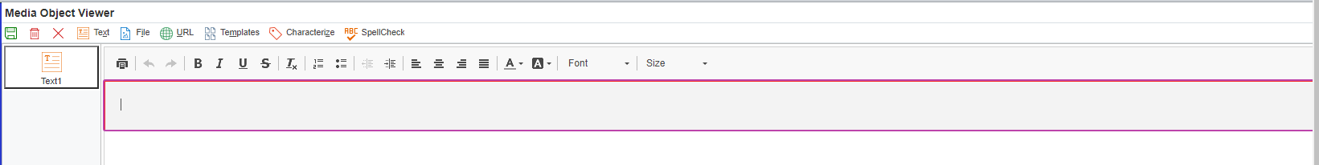

If the order number has any result the robot will select the first register and this will go to insert the reason of the credit note and it will save the changes.

Finally, the robot update information in **RunMyProcessData** and **CreditsNotesEmea** SQL tables

1. **Debit Notes**

The task that this process perform is **NavigateDebitNotes**

If the transaction is Debit Note the robot will go to credit memo and try search the order number. If JD Edwards finds the Order Number, the robot will select the first row in the JD Edwards result’s, the robot will then go to update information into “**JD Edwards-Enter new Order**” section. Finally, the robot update status and information in **RunMyProcessData** and **CreditsNotesEmea** SQL tables.





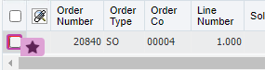





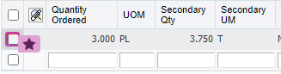

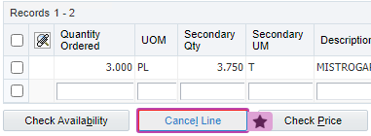



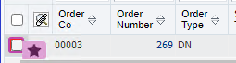

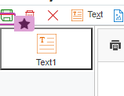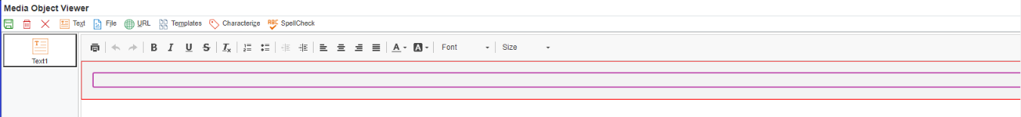

**ERROR HANDLING**

The possible errors in Credit Notes automation process are basically SQL Server connection and Recorder-Capture failure.

If the error is connection to SQL Server you must verify that these connections are working or that the server is running. Finally, you will can run the process again. Is possible executed the process again because if the process was not concluded, in the table **CreditsNotesEmea,** **CnDnNumber** field was not updated and the process can run again.

On the other hand, if the error is by Recorder-Capture failure you should verify that the JD Edwards login is working. JD Edwards login is working you should run the process again, if the process failed again you should verify